**GRADE 12 GEOGRAPHY RURAL SETTLEMENTS**

**RURAL SETTLEMENT ISSUES – CASE STUDIES**

Study the two case studies below and answer the questions based on them.

**CASE STUDY 1**

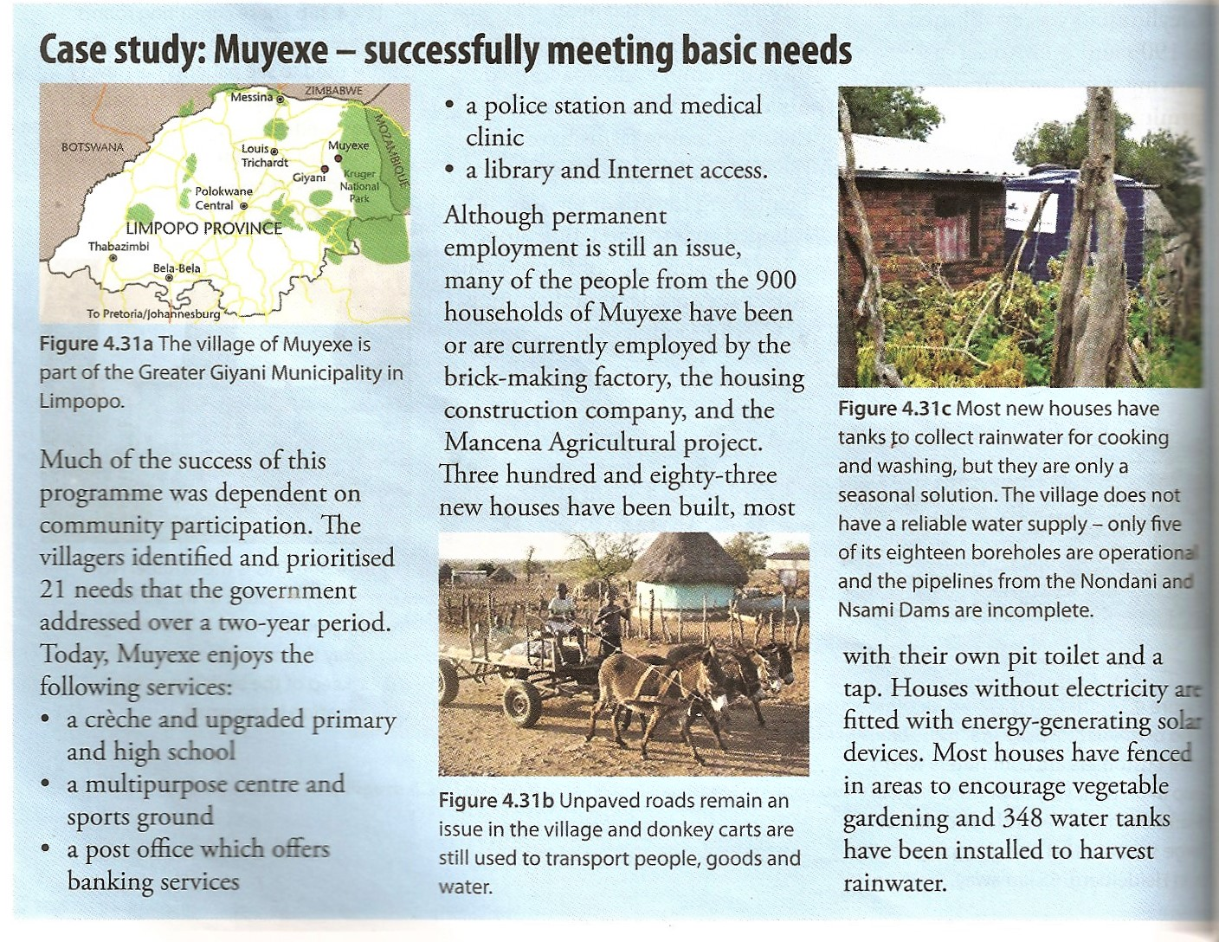

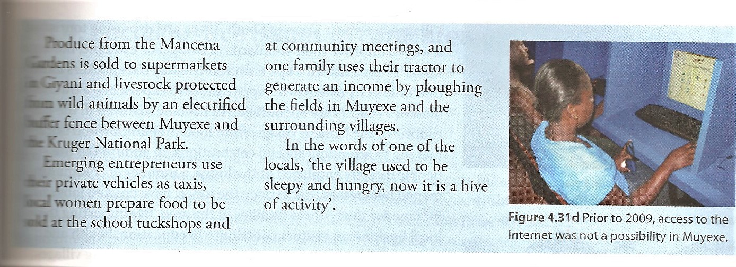

Source:Cohen, S et al. (2013) *Platinum Geography grade 12.* Cape Town. Maskew Miller Longman. Pp. 176-7

**QUESTIONS**

1. Make a list of basic needs that the pilot project met at Muyexe.

|  |
| --- |
|  |
|  |
|  |
|  |
|  |
|  |
|  |
|  |

1. List three needs which you would regard as important that do not seem to have been met at the time the case study was drawn up.

|  |
| --- |
|  |
|  |
|  |

1. Suggest at least one other possible economic activity that could be implemented to generate employment and income.

|  |
| --- |
|  |

1. Identify one situational factor that has contributed to the lack of development and the poverty in Muyexe.

|  |
| --- |
|  |

The following questions refer to Case study 2 below:

1. Explain briefly what the Betterment Programme was

|  |
| --- |
|  |

1. Explain what type of land reform programme the Cata Village case illustrates.

|  |
| --- |
|  |

1. What is the difference between land restitution and land distribution?

|  |
| --- |
|  |

**CASE STUDY 2**

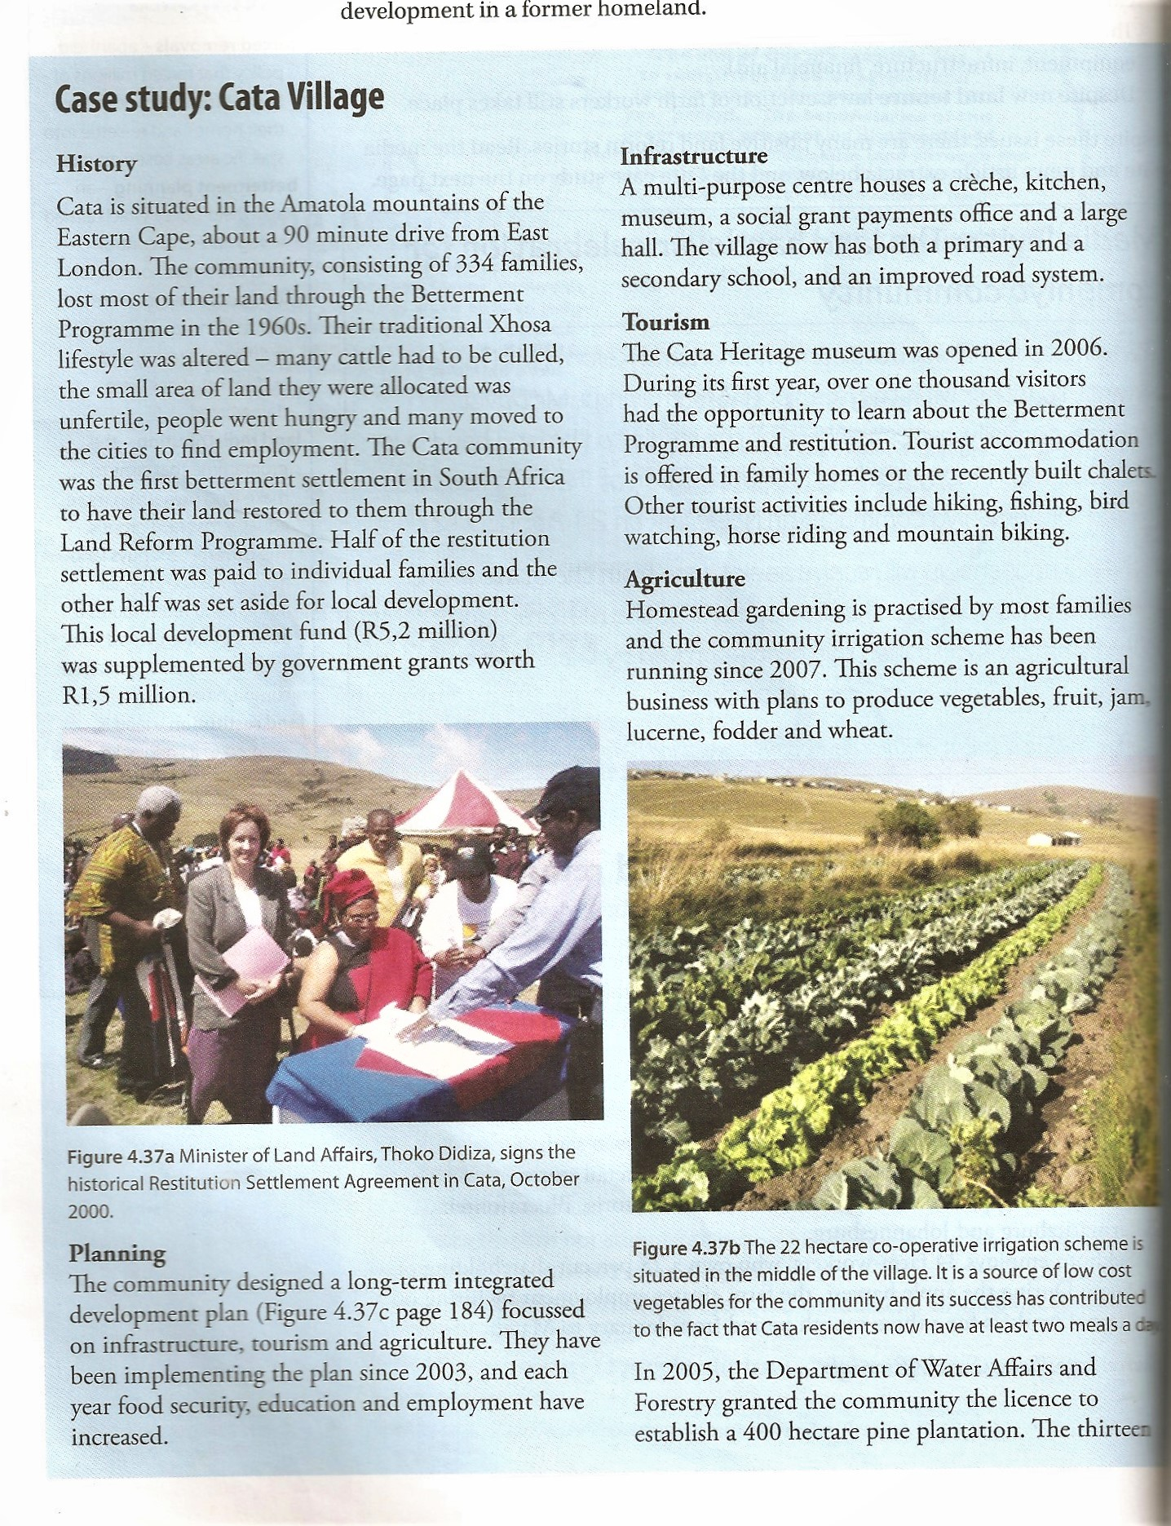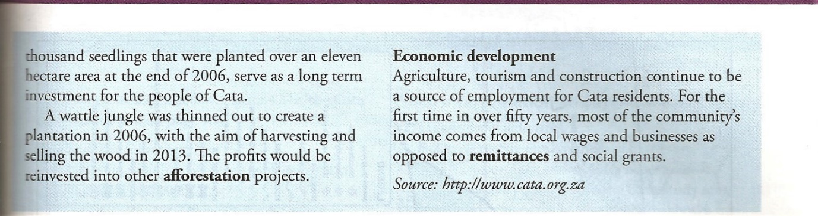

Source: Cohen, S et al. (2013) *Platinum Geography grade 12.* Cape Town. Maskew Miller Longman.pp182-183

1. State which of these two programmes has been more successful and give reasons for your opinion.

|  |
| --- |
|  |

**CASE STUDY 3**

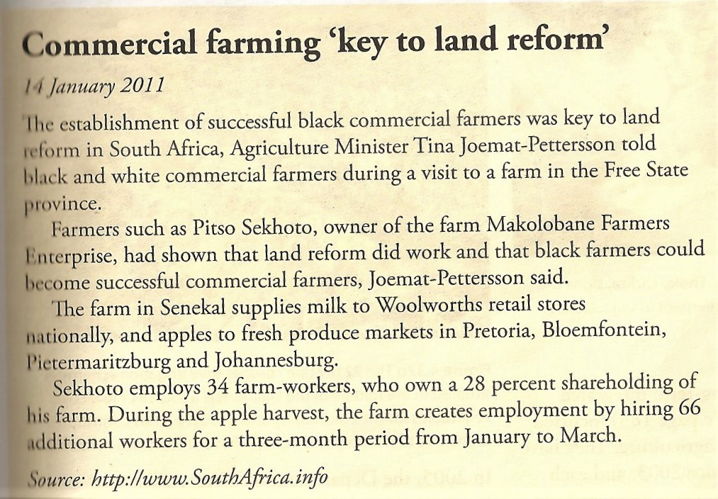

1. What type of land reform programme does the Makolobane case illustrate?

|  |
| --- |
|  |

1. Describe three frequently encountered problems of land reform that this case has managed to overcome.

|  |
| --- |
|  |
|  |
|  |