DRAINAGE PATTERN | SKETCH THE PATTERN AS SEEN ON A MAP | CHARACTERISTIC FEATURES | CAUSE
1. Dendritic | 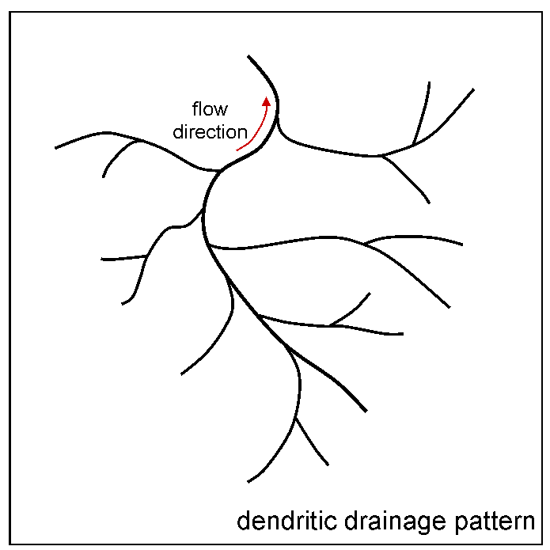 | Tributary confluences are acute angled | Any rock type; uniform slope and uniform resistance to erosion

