**[What is a heat wave?](http://www.weathersa.co.za/learning/weather-questions/346-what-is-a-heat-wave)**

There is a specific criterion that the South African Weather Service applies to each town or city, in order to determine whether heat wave conditions are met or not.

The criterion reads as follows: If the maximum temperature at a particular town is expected to meet or exceed 5 degrees C above the average maximum temperature of “the hottest month” for that particular place, as well as persisting in that mode for 3 days or more, then a heat wave may be declared. For ease of use by SAWS meteorologists, a detailed map of the “heat wave threshold” has been compiled (see figure 1 below), using the latest climatological data to hand. This threshold is thus the maximum temperature which needs to be met or exceeded, for a heat wave to occur.

**Heat wave temperature thresholds over South Africa**

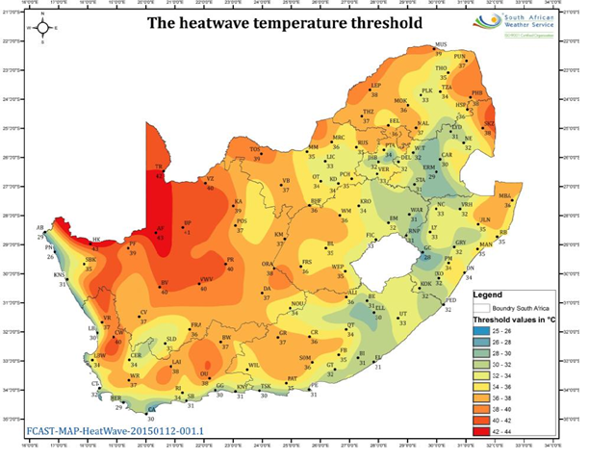

<http://www.weathersa.co.za/learning/weather-questions/346-what-is-a-heat-wave>

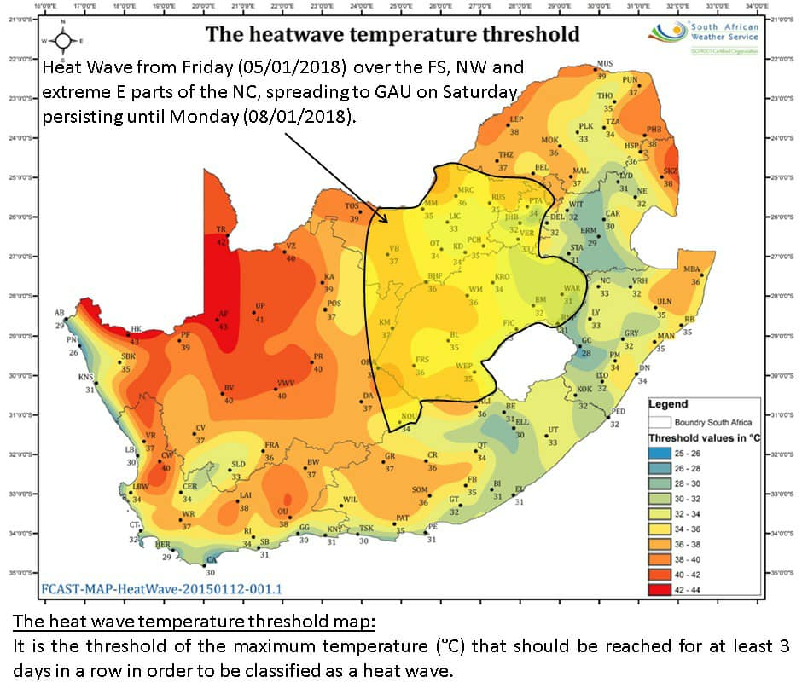

Heatwave to continue throughout weekend

WEATHER Friday 5 January 2018 - 12:40pm Contributors: [Lynette van Schalkwyk](https://www.enca.com/news-team/lynette-van-schalkwyk)

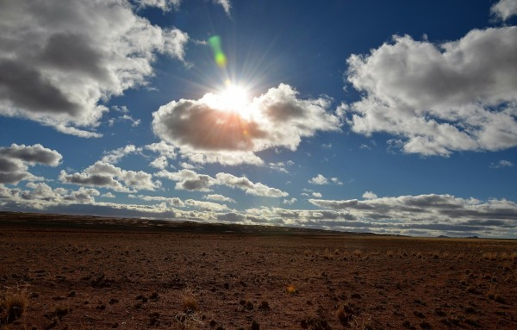

File: Cooler air will reach the eastern parts of South Africa and Gauteng by Tuesday when temperatures will return to the upper twenties again in Johannesburg. Photo: Pixabay / teetasse

CAPE TOWN - A very hot and dry weekend lies ahead for the central and eastern parts of South Africa, with heatwave conditions expected to last until Monday.

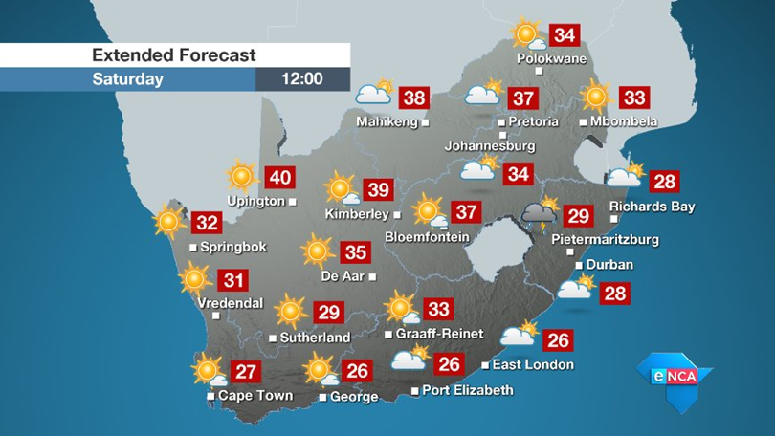

The heatwave is caused by an upper air high-pressure system that remains stagnant over the northern parts of southern Africa.

[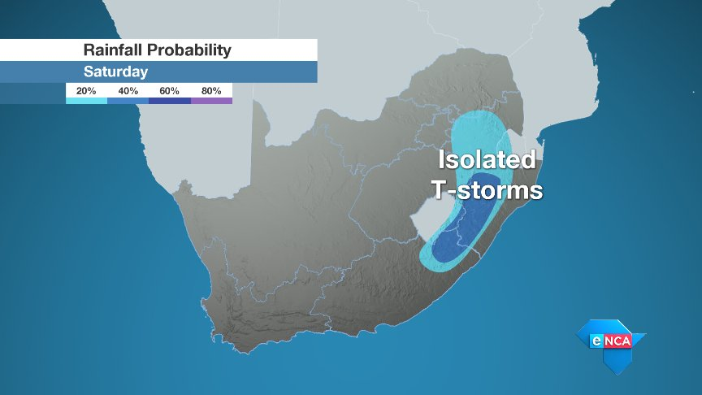](https://twitter.com/eNCA/status/949498322175381504/photo/1)

In order for a hot spell to be classified as a heatwave, temperatures have to exceed the average maximum temperature of the warmest month of the year (which is January or February for most places in South Africa) by 5ºC for three days or longer.

Luckily this heatwave will be relatively short-lived.

Cooler air will reach the eastern parts of South Africa and Gauteng by Tuesday when temperatures will return to the upper twenties again in Johannesburg.

It is at this point that thunderstorms will become likely once more on the Highveld.

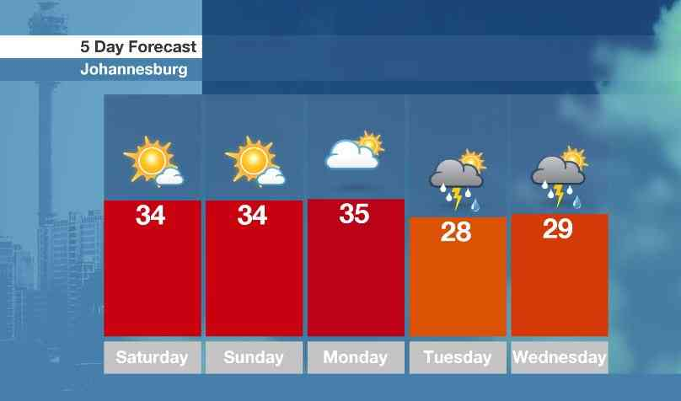

eNCA

Source: <https://www.enca.com/weather/heatwave-to-continue-throughout-weekend>