**CLIMATOLOGY PORTFOLIO TASK**



**GRADE 12**

**2020**

|  |  |
| --- | --- |
| Name |  |
| Date |  |

|  |  |  |  |  |
| --- | --- | --- | --- | --- |
| **QUESTION 1** | **QUESTION 2** | **QUESTION 3** | **QUESTION 5** | **TOTAL** |
|  |  |  |  |  |
| **28** | **32** | **18** | **22** | **100** |

**INSTRUCTIONS:**

1. This activity consists of13pages, a 3-page inset and an essay rubric.
2. You may use any resources.
3. Answer all your questions on the question paper.
4. Please write name on your paper.
5. Write neatly.
6. Good luck!!!



**QUESTION 1 - MID-LATITUDE CYCLONES**

Study the synoptic map in Figure 1 and then answer the questions.

**Figure 1: Synoptic chart for 17 July 2014**

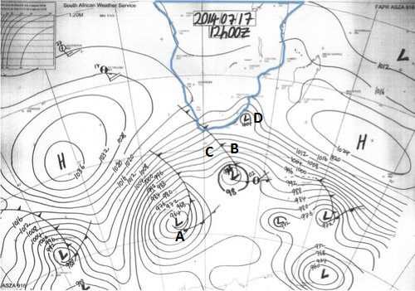

1.1 Identify the weather system at A. (2)

|  |
| --- |
|  |

1.2 Identify the stage of development of this weather system. Use evidence from the synoptic map to prove your answer. (4)

|  |
| --- |
|  |
|  |
|  |

1.3 Answer true or false and then account for your choice

a) The temperature at B will be warmer than the temperature at C. (4)

|  |
| --- |
|  |
|  |
|  |

b) The weather system at A will move in a southerly direction. (4)

|  |
| --- |
|  |
|  |
|  |

c) The system at D is a cut-off low. (4)

|  |
| --- |
|  |
|  |
|  |

1.5 Draw a well-labelled cross-section from C to B in Figure 1 to show air masses, cloud type, front and precipitation. (10)

**[28]**

**QUESTION 2 – CYCLONE AVA**

Study the images of Cyclone Ava and the information below.

**Figure 2A: Satellite image of Cyclone Ava**

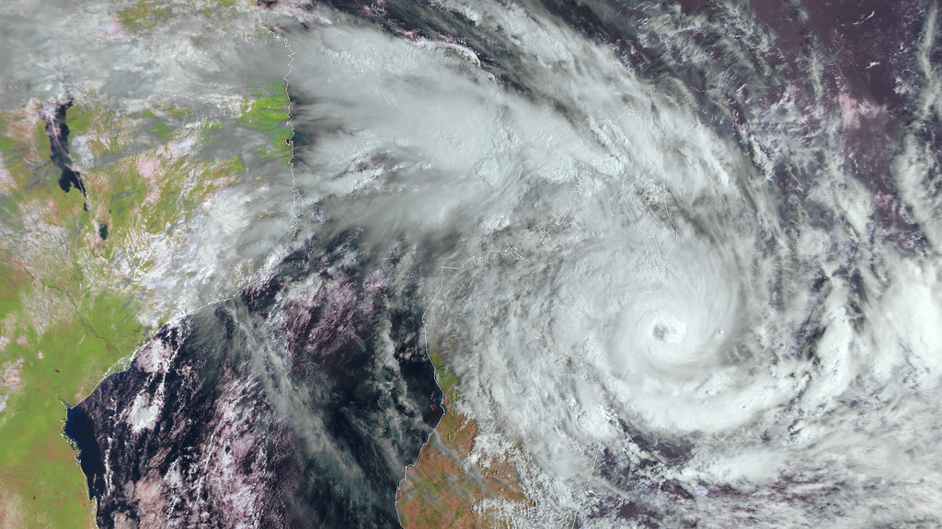

C

B

A

<https://c1.staticflickr.com/5/4596/39515082811_50207b876d_b.jpg>;

Copyright: 2017 [EUMETSAT](http://www.eumetsat.int/)

**Figure 2B: Path of Cyclone Ava**

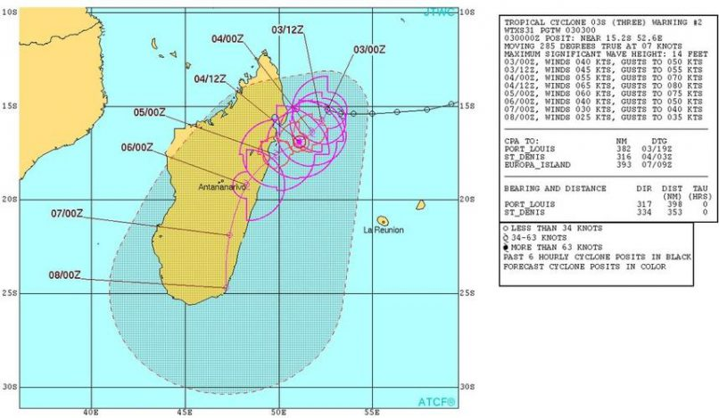

<https://citizen.co.za/wp-content/uploads/sites/18/2018/01/aa0401cyclone1_81069_tn-806x469.jpg?x68991>

**Figure 2C: Potential track**

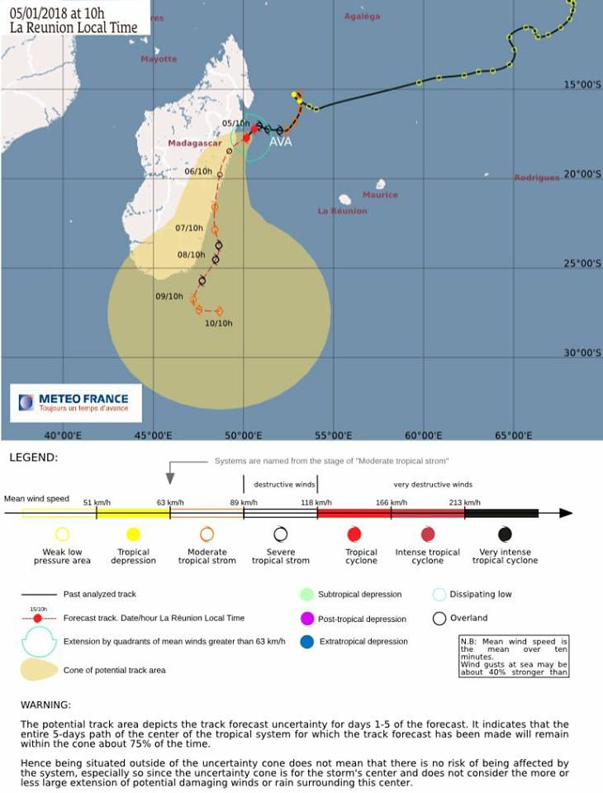

<https://scontent-jnb1-1.xx.fbcdn.net/v/t1.0-9/26230136_737223673147625_149157842281691880_n.jpg?oh=6ee27906611c55c5a265fb0d0b46ecb7&oe=5AF8332E>

**Figure 2D: Article**

**Cyclone Ava kills at least 29 in Madagascar** Tuesday 9 Jan 2018

A few days after cyclone Ava made landfall on Madagascar, its devastating impact is starting to become clear.

The tropical storm hit the island country off the south-eastern coast of Africa on Friday 5th and Saturday 6th January, killing at least 29 people nationwide and forcing more than 17,000 from their homes.

A statement by the National Bureau for Risk and Catastrophe Management said that 22 people were still missing by Monday. Overall, Ava affected more than 83,000 people.

The cyclone struck the eastern part of Madagascar the hardest. There, towns flooded and buildings collapsed. Roads were also damaged and communications were knocked out.

"There was a huge amount of rainfall and very strong winds. As a result, houses have collapsed and buildings have fallen on top of people," Samantha Cameron, an aid worker, told Al Jazeera from the southcentral city of Fianarantsoa.

"A lot of the roads have been cut off and some emergency measures have been taken to rebuild the main road between here and the capital, Antananarivo. But progress has been slow," added Cameron, who works for Feedback Madagascar, an international group focused on poverty reduction in the country.

Cameron said that at least 16 schools in five municipalities were believed to had been destroyed.

"Some towns are still flooded and the phone network is down, which makes communicating with these places even harder."

Destructive impact

Madagascar, the world's fourth-largest island, is regularly hit by cyclones between the months of November and April.

In March 2017, tropical cyclone Enawo slammed into the northeast of the country, killing at least 80 people displacing almost a quarter of a million. "Enawo was the strongest cyclone to hit Madagascar in 13 years, with winds of 230kph, the equivalent of a Category 4 hurricane", said Al Jazeera meteorologist Steff Gaulter.

Gaulter said the heavy downpours brought by Ava led to mudslides and flooding in Madagascar, while on the neighbouring island nation of La Reunion, the capital of Saint-Denis was drenched by 50mm of rain.

Madagascar is one of the poorest countries in the world, with its Gross Domestic Product ranking 164th out of 175 countries, according to the World Bank.

Cameron said that a destructive storm like Ava meant that the country's impoverished citizens would now have to face further challenges.

"Crops are destroyed and roads are inaccessible," she said.

"An event like this is felt even more by the population because they have less economic possibilities to recover," added Cameron.

"But the sun came out today, so we are happy the worst of the storm has passed."

***With reporting by Yarno Ritzen***

SOURCE: AL JAZEERA NEWS

2.1 Identifythe cyclonic feature labelled A on the satellite image in Figure 2A. (2)

|  |
| --- |
|  |

2.2 Identifythe type of cloud labelled B. (2)

|  |
| --- |
|  |

2.3 Name the direction of circulation at C. (2)

|  |
| --- |
|  |

2.4 Propose an appropriate name for the tropical cyclone that came after Tropical Cyclone Ava. Motivate your choice of name (do not state “as it came after it” as your answer). (4)

|  |
| --- |
|  |
|  |
|  |
|  |

2.5 Convertthe satellite image shown in Figure 2A, into a synoptic map representation of Tropical Cyclone Ava. Your synoptic map representation must illustrate the following:

* isobars with appropriate values
* the symbol
* any other applicable features. (8)

2.6 The article states that “The cyclone struck the eastern part of Madagascar the hardest”. Account for this statement. (4)

|  |
| --- |
|  |
|  |
|  |
|  |

2.7 Explain fully why Madagascar is “regularly hit by cyclones between the months of November and April”. (4)

|  |
| --- |
|  |
|  |
|  |
|  |

2.8 Madagascar is regularly hit by cyclones, but is still devastated. Analyse why this is the case. (6)

|  |
| --- |
|  |
|  |
|  |
|  |
|  |
|  |
|  |
|  |
|  |
|  |
|  |
|  |

**[32]**

**QUESTION 3 - GENERAL CIRCULATION AROUND SOUTHERN AFRICA**

July 2016 saw a very strong cut-off low affecting SA over a period of a week. Study the tweet (Figure 3A), the synoptic chart (Figure 3B) and Figures 3C and 3D of the Black South Easter.

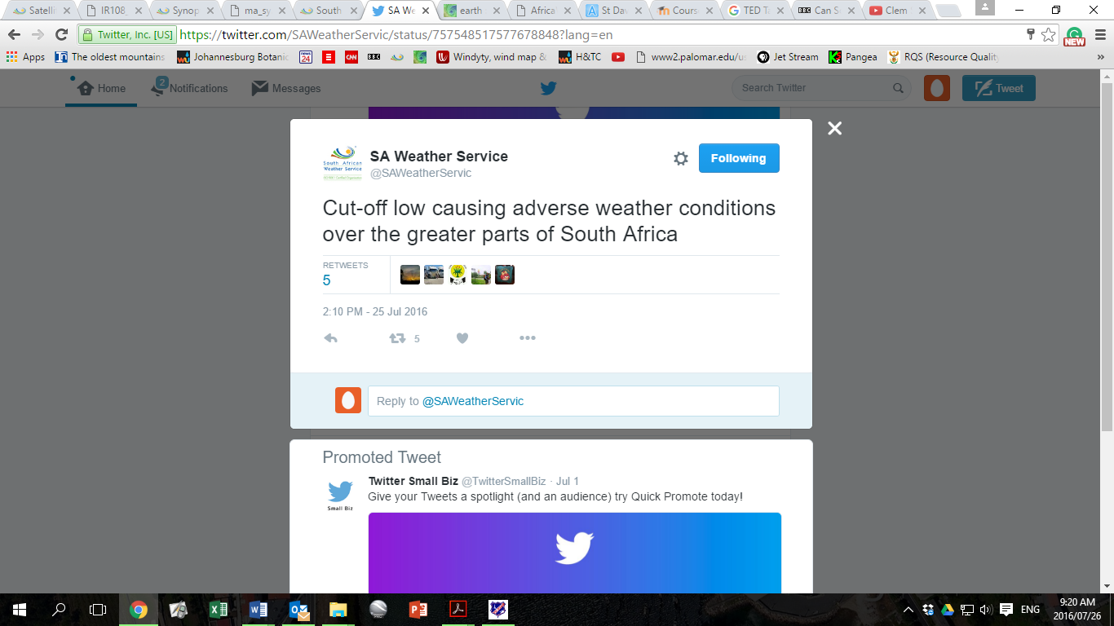**FIGURE 3A - Tweet by the South African Weather Service**

Source: SAWS

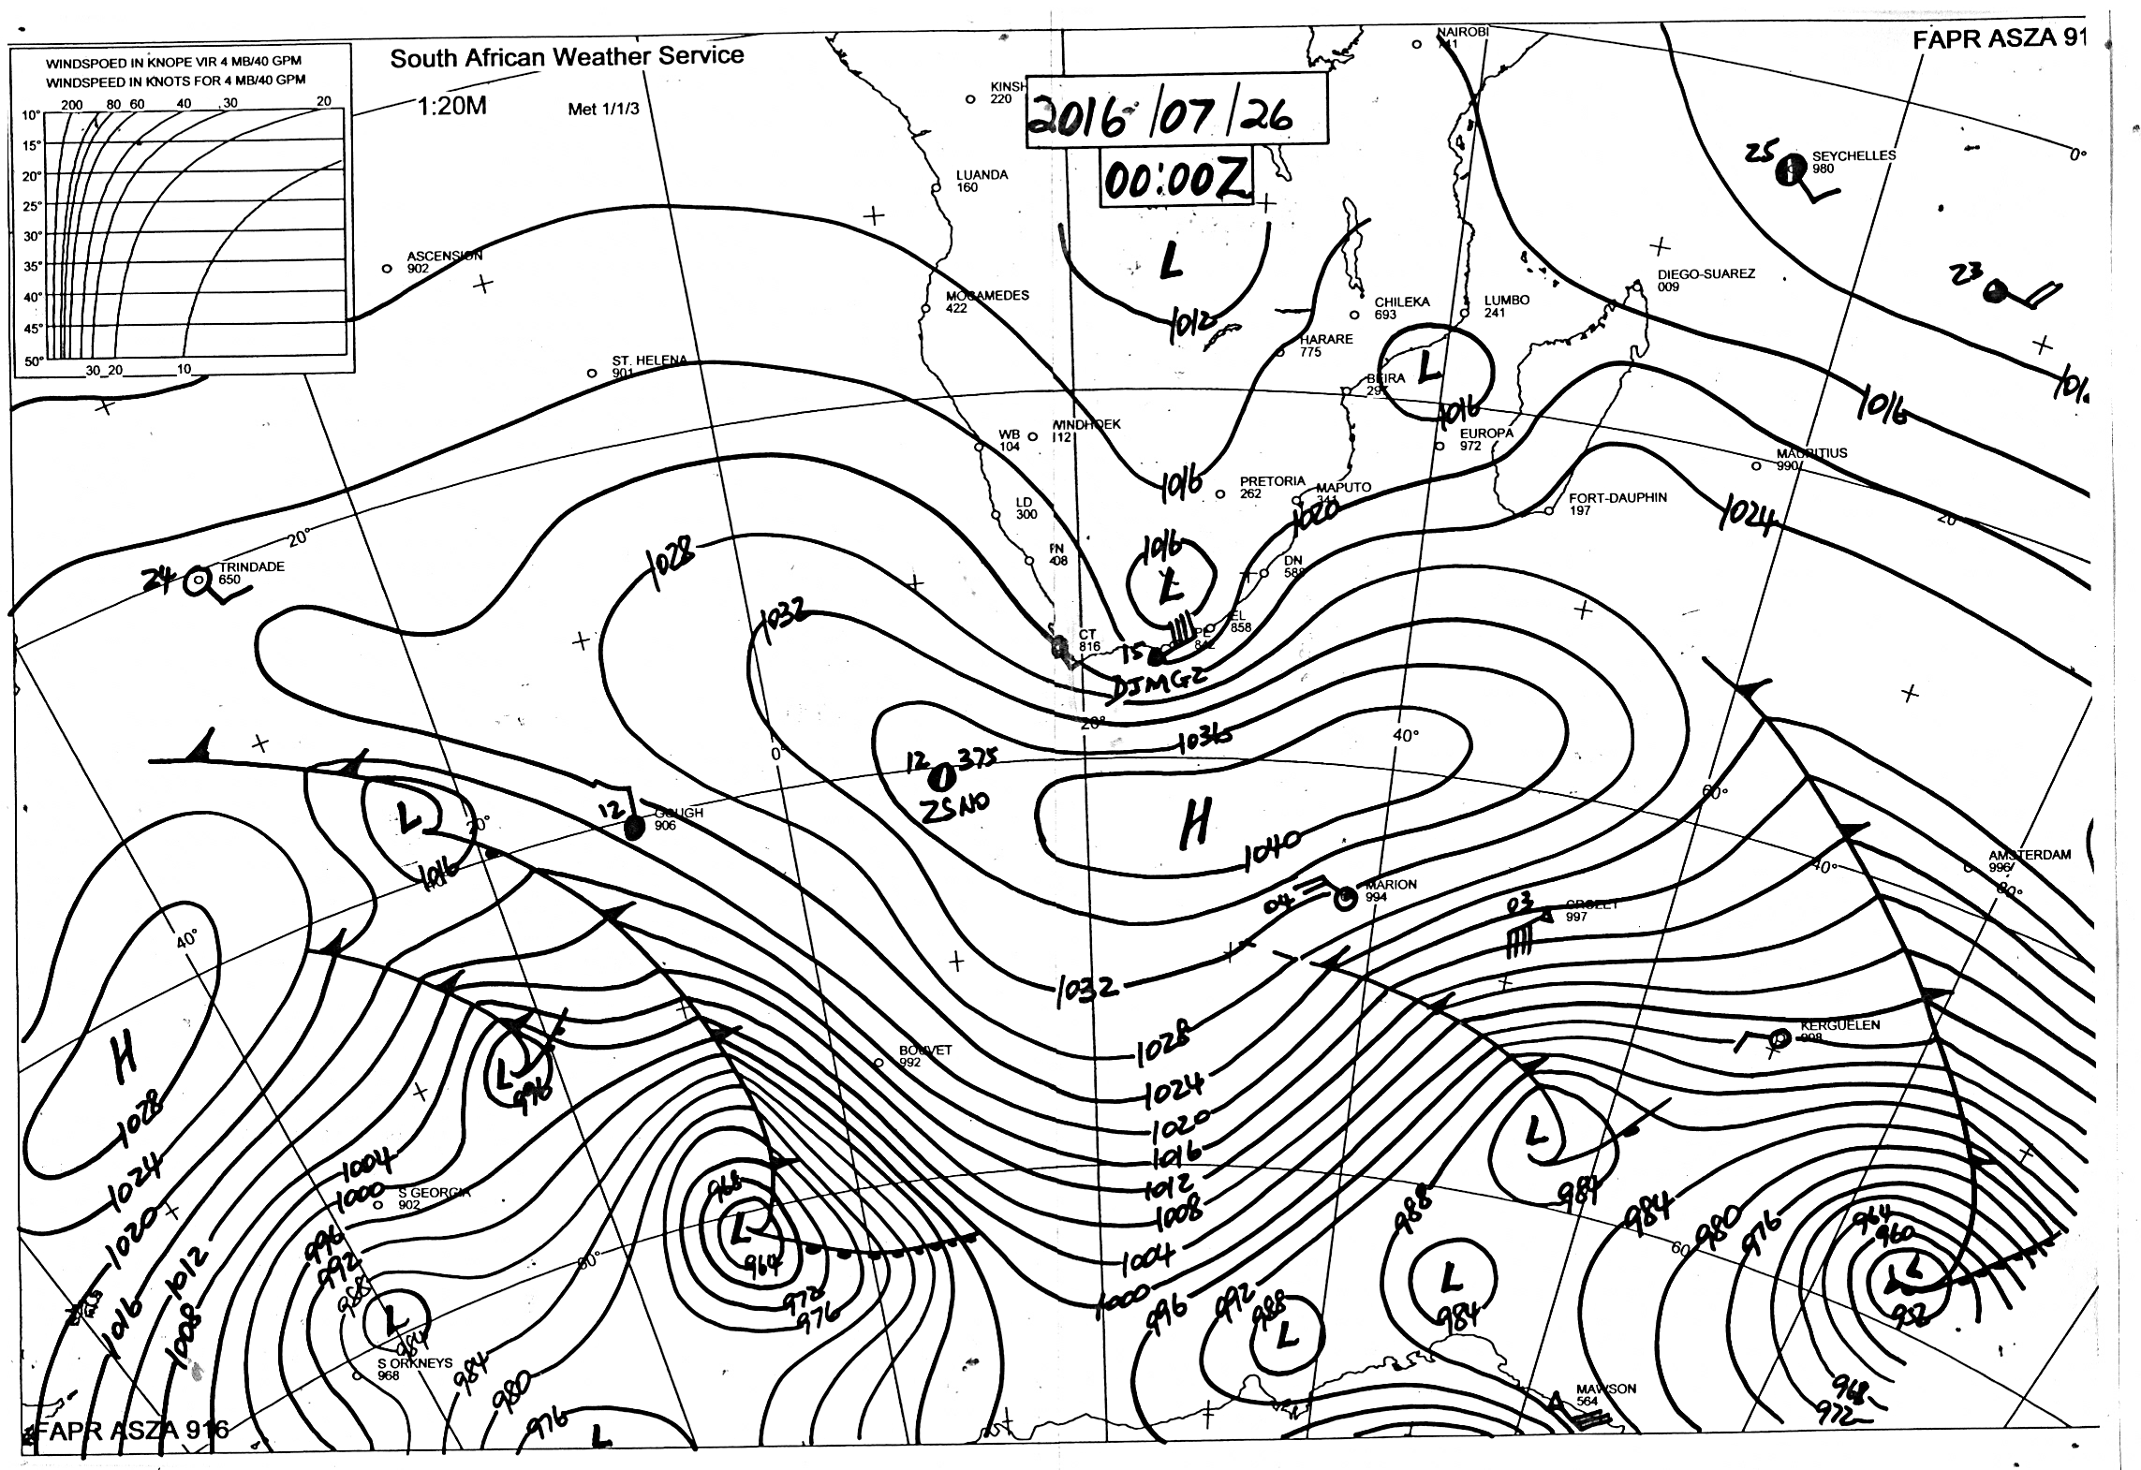**FIGURE 3B - Synoptic chart showing the cut-off low**

**X**

Source: SAWS

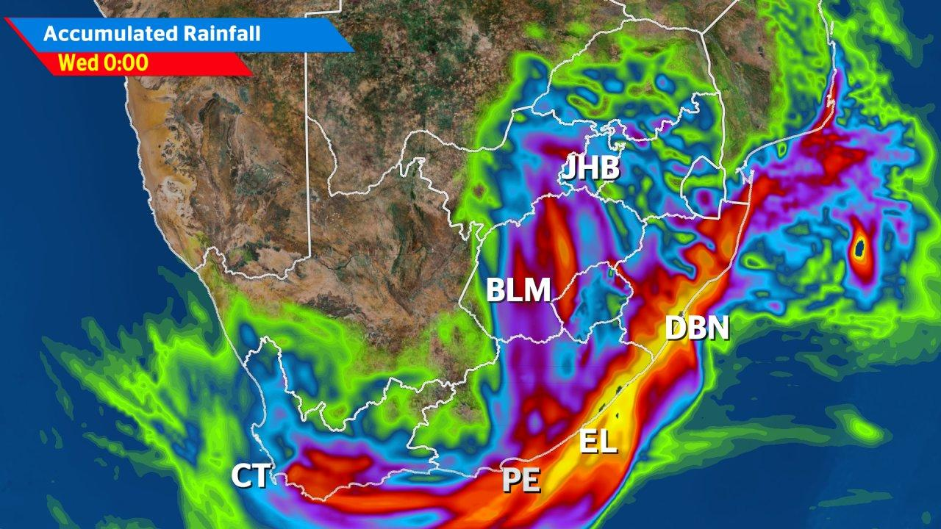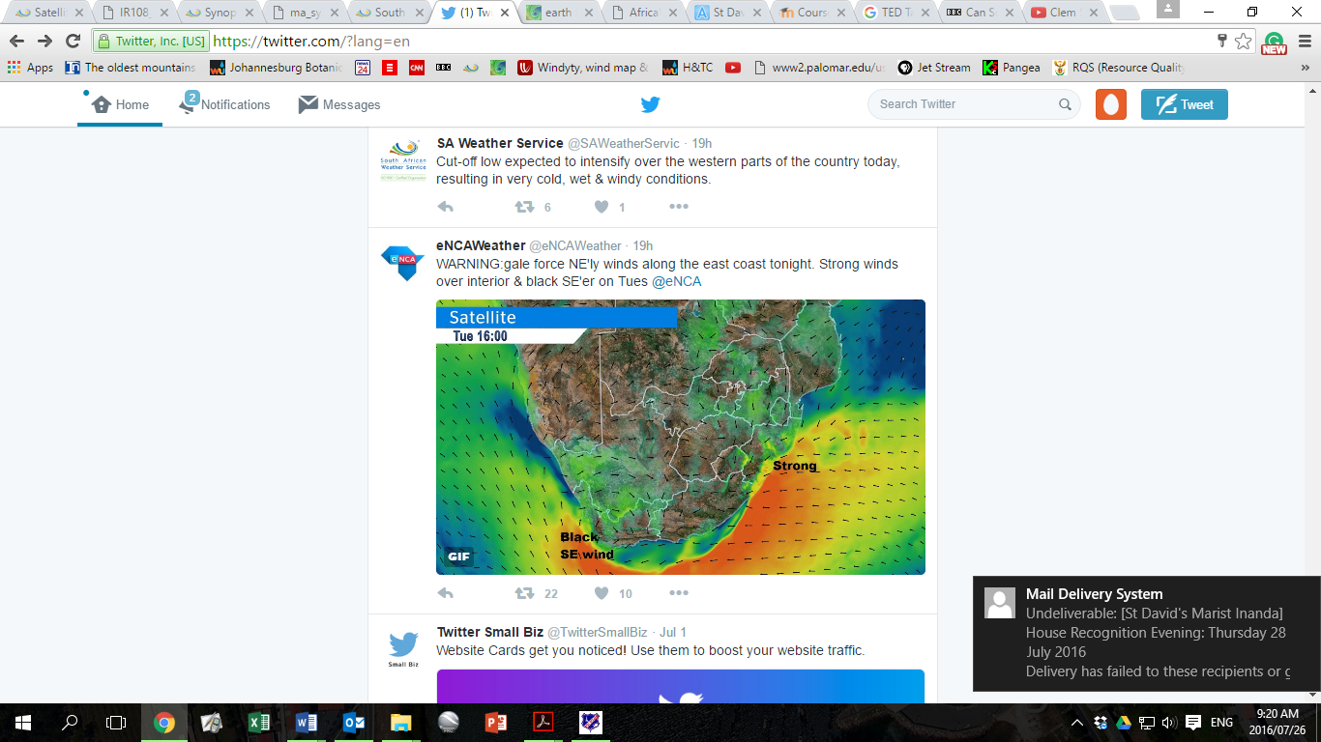**FIGURE 3C: A Tweet by eNCA FIGURE 3D: weather forecast by eNCA**

(source: eNCA)

3.1 Name the term used to describe the shape of the high pressure system at X (Fig 3B). (2)

|  |
| --- |
|  |

3.2 Explain how a cut-off low is formed over South Africa. (4)

|  |
| --- |
|  |
|  |
|  |
|  |
|  |

3.3 Describethe conditions associated with this system. (4)

|  |
| --- |
|  |
|  |
|  |
|  |
|  |

3.4 Name the anticyclone responsible for the formation of a Black South Easter. (2)

|  |
| --- |
|  |

3.5 With the aid of a diagram explain how a Black South Easter is formed. (6)

**[18]**

**QUESTION 4**

Refer to the insert “What is a heat wave”. Write an essay in which you expand on how subtropical anticyclonic conditions and associated weather conditions can influence SA’s climate. In your essay take care to discuss recent events under the following headings:

* How anticyclones’ subsidence can lead to a heat wave (you may include diagrams)
* The weather systems that can lead to mid-summer rainfall
* Possible impact of Cyclone Ava

Refer to the attached rubric when planning and structuring your essay. (22)

|  |
| --- |
|  |
|  |
|  |
|  |
|  |
|  |
|  |
|  |
|  |
|  |
|  |
|  |
|  |
|  |
|  |
|  |
|  |
|  |
|  |
|  |
|  |
|  |
|  |
|  |
|  |
|  |
|  |
|  |
|  |
|  |
|  |
|  |
|  |
|  |
|  |
|  |
|  |
|  |
|  |
|  |
|  |
|  |
|  |
|  |
|  |
|  |
|  |
|  |
|  |
|  |
|  |
|  |
|  |
|  |
|  |
|  |
|  |
|  |
|  |
|  |
|  |
|  |
|  |
|  |
|  |
|  |
|  |
|  |
|  |
|  |
|  |
|  |
|  |
|  |
|  |
|  |
|  |
|  |
|  |
|  |
|  |
|  |
|  |
|  |
|  |
|  |
|  |
|  |
|  |
|  |
|  |
|  |