**LIFEBRIDGE GR. 8 SOCIAL SCIENCES**

**TASK SHEET 1 TRADE AND TRANSPORT**

|  |  |  |  |
| --- | --- | --- | --- |
| Time frame | 1 day | Total marks | / 35 |
| **Name** |  | **Date** |  |

**Instructions**

Complete this task sheet during the class discussion

How would you explain to someone what is meant by the term “trade”? (2)

|  |
| --- |
|  |

Complete the following two sentences: (2)

|  |
| --- |
| **International trade** is trade between |
| **Domestic trade** is trade between |

Why do people and countries trade with each other? Can you think of three reasons why we buy things from other countries?

|  |
| --- |
|  |
|  |
|  |

(3)

What are three things that South Africa has so much of that it can supply it to other countries?

|  |
| --- |
|  |
|  |
|  |

(3)

Look at the photographs below and answer the questions that follow them

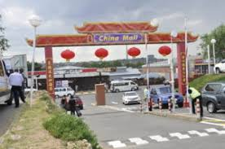

|  |  |
| --- | --- |
| 1. This shopping mall is in South Africa so why is it called China Mall? |  |
| 1. Name three items you use at home that come from another country. |  |
|  |
|  |
| 1. From what countries do they come?. |  |
|  |
|  |
| 4. What kind of transport might have been used to bring these items to South Africa? |  |
| 5. How could the type of transport used affect the price of the items? |  |

(5)

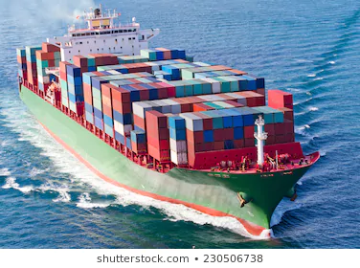

|  |  |
| --- | --- |
| 1. What sort of ship is this? |  |
| 1. What sorts of cargo are usually in the containers? |  |
| 1. Why are ships used for transporting goods over long distances instead of aeroplanes |  |
| 1. How do containers make the moving of goods on ships more effective? |  |
| 1. Some types of goods are rather sent by aeroplane than by ship? Why? Name one such product. |  |
| 1. Can you suggest two reasons why goods for trade that would normally be sent by sea would be sent by road or rail transport? |  |

(10)

In the table below different types of transport are compared. Complete the table by filling in what each type of transport is particularly useful for (10)

|  |  |  |  |
| --- | --- | --- | --- |
| **Air transport** | | **Rail transport** | |
|  | |  | |
| **Sea transport / Shipping** | |
|  | |
| **Road transport** | | **Pipelines** | |
|  | |  | |

(10)