**LIFEBRIDGE GRADE 10 LEVEL GEOGRAPHY / ENGLISH / LIFE ORIENTATION ASSIGNMENT**

**THEME: PEOPLE EVERYWHERE**

**TOPIC: POPULATION DISTRIBUTION, DENSITY AND GROWTH**

**OUTCOMES**

When you complete this assignment, you will be able to:

1. Explain the concepts *population distribution, density and growth.*
2. Identify and explain the factors that influence and affect distribution and growth of population
3. Explain the concept demographics and explain what a demographer does
4. Explain what is meant by birth rate, death rate, fertility rate population explosion and natural increase
5. Evaluate different ways of communicating information about population density and distribution.
6. Identify and evaluate different problems and benefits of dense and sparse populations
7. Demonstrate how to calculate population density.
8. Demonstrate how to interpret graphs and tables relating to population trends
9. Explain the four stages of the demographic transition model and provide reasons why this model may be accurate and what it implies
10. Discuss the concept of overpopulation and suggest ways countries and communities can manage the impact of population on the environment.

**INPUTS**

1. Winter, K., Oelofse, C., and S. Zukulu (2005) *In Search of Geography.* Oxford University Press. Cape Town
2. Blaauw, M., Blackbeard, A., Brouard, J., Marchant, J., Mofokeng, M., and E. Oberholster (2008) *Spot On Geography Learner’s Book.* Heinemann. Cape Town
3. <https://sedac.ciesin.columbia.edu/downloads/maps/gpw-v4/gpw-v4-admin-unit-center-points-population-estimates-rev11/gpw-v4-admin-unit-center-points-population-estimates-rev11.png>
4. <http://www.geography.learnontheinternet.co.uk/topics/popn1.html>
5. [www.internetgeography.net/topics/what-is-population-distribution/](http://www.internetgeography.net/topics/what-is-population-distribution/)
6. <https://www.internetgeography.net/topics/what-factors-affect-population-density/>
7. <https://www.internetgeography.net/topics/what-causes-population-change/>
8. <https://ourworldindata.org/world-population-growth>
9. Discussions with teacher

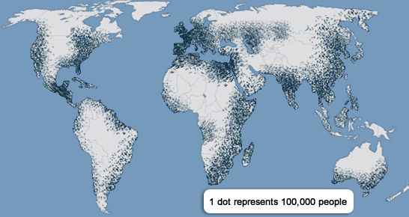

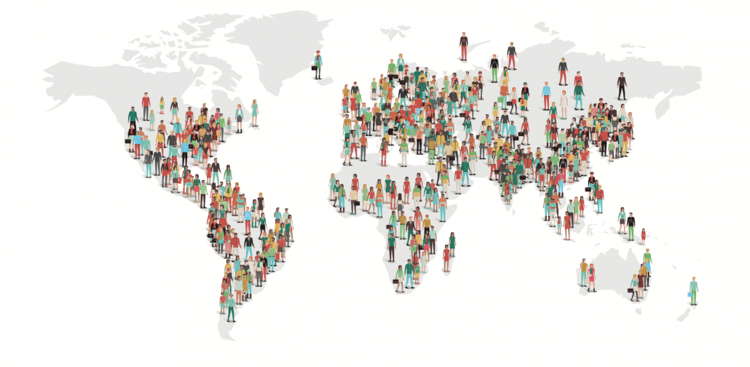

**TASKS [70 marks]**

1. Compare the two population maps above and:
2. State what they suggest about the way the population of the world is distributed. (2)
3. Explain which areas are most sparsely populated and why. (4)
4. List factors that affect where the population is likely to be most dense (4)
5. Compare the way in which the two maps above present the information and state the advantages and short comings of each type of map. (4)
6. Explain when it would be best to use each of the following ways of communication about population:

* A map
* A graph
* A table of figures (5)

1. Refer to Winter et.al. pp 144-145 and:
2. Identify and explain three reasons why the world’s population has grown so rapidly since 1950 (6)
3. Complete the questions under activity 3 on pg. 145 and Activity 4 on page 146. (20)
4. Study the diagram on pg. 140 of Blaauw et al. and answer the following questions:
5. What is a population explosion? (1)
6. What are the effects of a population explosion? (2)
7. What is the demographic transition model? (4)
8. Is the world’s population still growing as rapidly or not? Give an explanation for you answer (3)
9. Use a table to explain what can cause the rate of natural increase to change including factors that change the birth and death rates. (5)
10. If we accept the idea of overpopulation who decides who are the excess people and how do we deal with them. Is there a different way to think about managing population growth that recognizes the possibility that God is a moral God? Write a short mini-essay in which you explain what you think individuals and governments should do to confront the issue of population increase in a responsible way (200-300 words) (10)

**ASSESSMENT**

This project will contribute towards 25 % of your term mark for Geography, 10% of your English mark and 10 % of your Life Orientation mark.

**SUBMISSION**

Your finished submission must be neatly hand written or typed out using Arial 12 and 1.15 spacing and placed in your work book and submitted to Mr Rich on **Tuesday 30 July 2019**